Though the 1990s is remembered as an extended period of economic prosperity during which GDP increased continuously for almost ten years (the longest recorded expansion in the history of the United States), our team decided to take a closer look at the job report from 1994 to identify trends and correlations between different variables in the job market.

Our data visualization analysis pays special attention to the gaps identified. We have used bar charts to compare how one parameter behave regarding another.

It is important also to note that one common denominator is the split in capital gains and salary from other variables. And for that reason we thought it was convenient to compare the present value of the dollar compared to the purchasing power of one dollar in 1994.

Our sample size is composed of an initial data set of 32561 records which was cleaned to 30148 unique records with supporting evidence for the analysis

According to Saving.org the current value of $5000 in year 1994 is around $84,541.84 and this is data used for validation.

https://www.saving.org/inflation/inflation.php?amount=100&year=1994

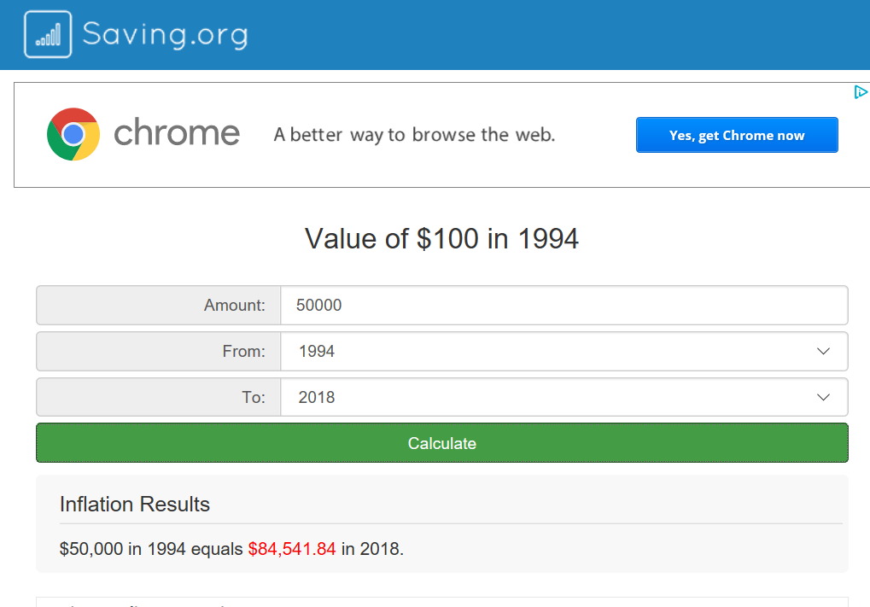

Trends

Education Vs Income:

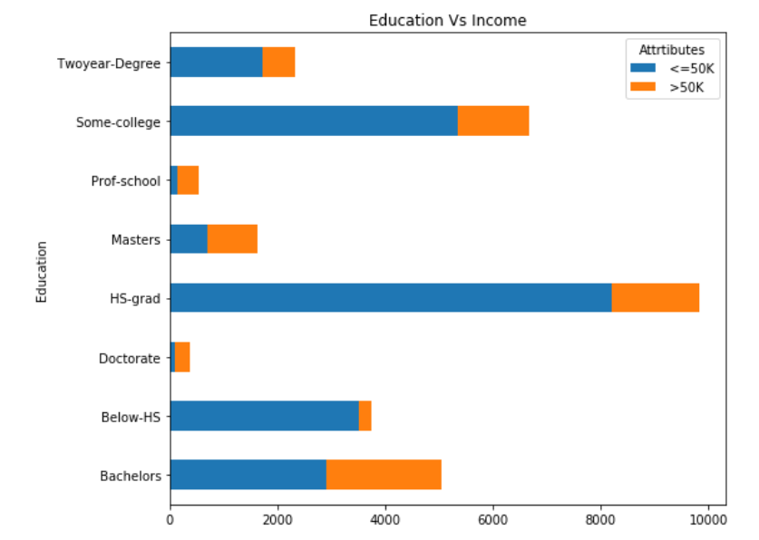

It is conclusive as per this analysis that a large part of the population selected in this sample size made a salary over $50K ($85K today) even though they did not have post high school education and on the other side of the spectrum only a small segment of this sample size had achieved a doctorate degree which was not determinant of higher compensation, as a matter of fact some of those that fell into this category made under $50K a year.

Even more surprising is that close to 10% of the sample size with education below HS also made over $50 K a year. It is therefore conclusive based on this analysis that even though there is correlation between education and salary; there is not direct equivalency of higher education as indicator of higher salary.

Gender

It has been in the news for many years that there is a gap in earnings based on gender. Our analysis found evidence of this claim in the 1994 census studied. It is conclusive that less than 5% of women at work achieved salaries over $50 K.

Though the causes are not evident in this study; other charts can draw conclusions that maybe motherhood and education opportunities have to do with the continuous trend of earnings discrepancies.

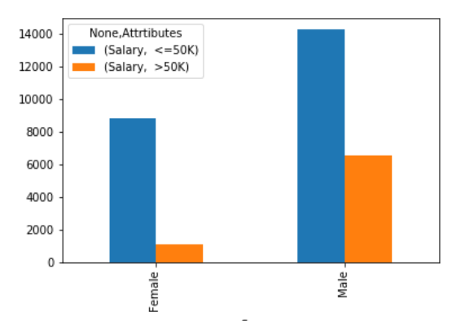 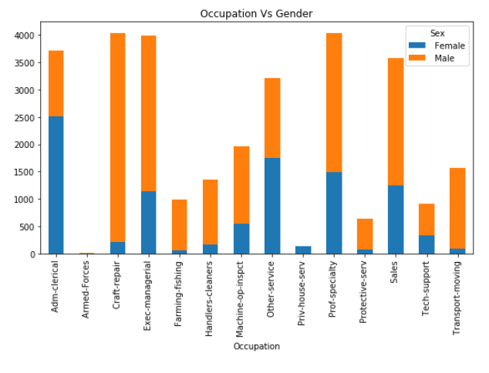

To get an insight to one possible cause, it is necessary to look at the occupations chart. As per this chart it is conclusive that female population was highly condensed in the Admin-clerical category where the possibilities of advancement might have been substantially more limited than Exce-Managerial where a higher percentage of male population was allocated.

From a different approach, it is also visible that education opportunities for males seem to have been more prominent. For example the bar for bachelor degree shows that 10% of the sample size achieved a bachelor degree whereas only 5% being female achieved the same degree.

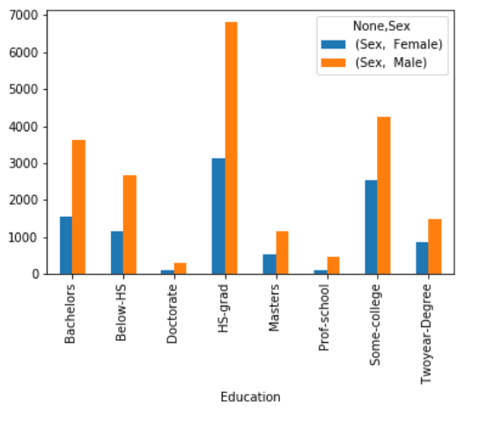

Workclass

In the private market the gap in income equality is highly evident. It is conclusive that only a bit over 10% of the sample size achieved salaries higher than the metric given $50K which is confirmation of the previous data provided that shows gender and education as factual elements for this outcome.

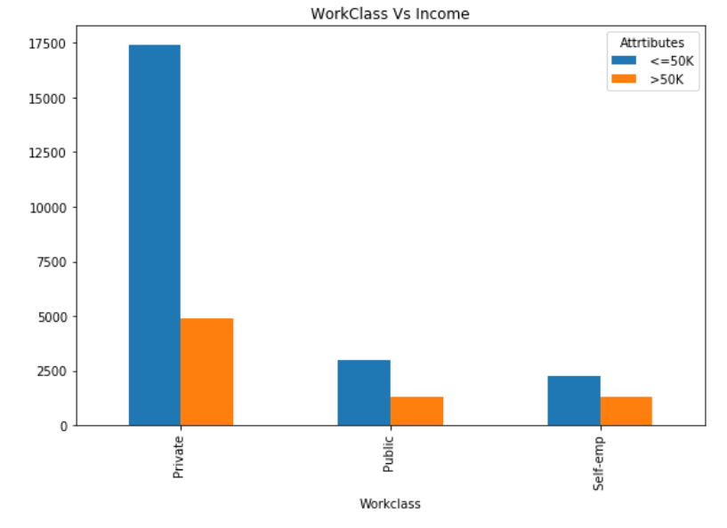

Marital Status

The analysis shows conclusive evidence that being married is a highly correlated factor regarding to income. It is conclusive that 85% of the sample size with salaries over $50K belongs to the category of married

It is also conclusive that married people who hold a post high school education account for over 40% of sample size with income equal or higher than $50K.

We can also say 7% of the sample size with income over $50K were single or never married. It is therefore evident that being single was counted as a negative metric at the moment of hiring perhaps because of lack of stability in the work force.

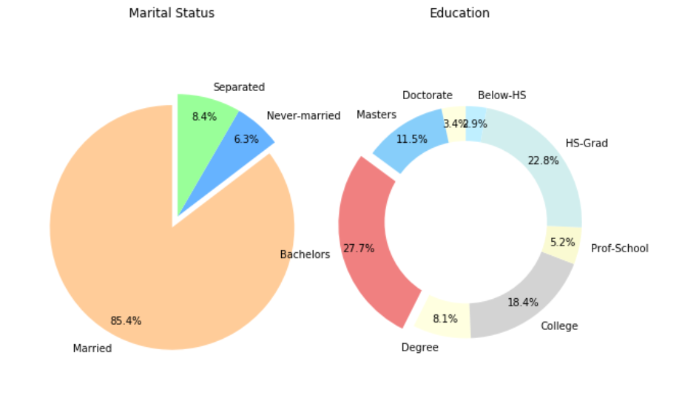

Hours worked vs Gender and Marital Status

The analysis also shows the relationship between hours worked and marital status. The possible outcome of this validation is that the population of this sample size with salaries over $50K put more hours at work in 100% of the cases. So overtime might have something to do with it.

Grouping of hours work per gender is not conclusive as a correlation of hours work vs gender as factor for income inequality though it is possible that the female population might have had limited access to extended hours because of family obligations

